Azure SQL DW Lab Introduction

**Overview**

In this workshop, you will work on a series of lab modules that teach you best practices for getting the most out of your Azure SQL Data Warehouse. These modules cover the entire lifecycle of data in your Azure SQL Data Warehouse from loading, to securing, querying, and optimizing the data.   
  
The dataset you’ll be working with is weather data from the National Oceanic and Atmospheric Organization (NOAA)

**Pre-requisites:**

Azure resources (Will be provisioned for you after following the lab initialization steps below)

* Azure SQL Data Warehouse
* Azure Data Lake Storage (Gen2)

Student Machine (latest versions of the tools below)

* SQL Server Management Studio (SSMS)

<https://go.microsoft.com/fwlink/?linkid=2104251>

* Azure Storage Explorer
* Azure Data Studio

**Lab initialization:**

1. Create your Azure lab environment

Click on the link below to create your Azure lab environment with all the necessary services. Please note that the environment is available for 10 hours since the time you sign up for it. Once the environment has been created, you will be presented with the login credentials to Azure portal and other relevant details. *Record these details in a safe location*.

Sign-up link : [http://bit.ly/2mG5PaZ](https://nam06.safelinks.protection.outlook.com/?url=http%3A%2F%2Fbit.ly%2F2mG5PaZ&data=02%7C01%7Ckalyany%40microsoft.com%7C12782a2d826b4f70ecf908d74289f7fd%7C72f988bf86f141af91ab2d7cd011db47%7C1%7C0%7C637051032827911494&sdata=%2BI4rQE5b%2BZ6vik6IqXiT5TCn7UFA%2F5lgArZ22lZmF0o%3D&reserved=0)

Activation Code : ACTIVATE4253

1. Log into Portal

Open your internet browser in safety mode (InPrivate) and navigate to portal.azure.com and enter the login credentials.

1. Start your SQL DW Instance

Click on ‘All resources’ and select your SQL Data Warehouse (AdventureWorksDW).

Click on ‘Resume’ to start your SQL DW instance

1. Configure SQL Server Firewall Settings

Click on the SQL Server name

Click on ‘Show Firewall Settings’

Click on ‘Add Client IP’ and click ‘Save’

This will add your client IP address to the firewall so you can use client tools on your laptop to access your Azure SQL Server.

1. Access Key

Click on ‘All resources’ and select the gen1 storage account from the list (it starts with the name ‘g1stor’)

Click on ‘Access Keys’ and note down the storage account name and access key details

1. Open SQL Server Management Studio on your laptop and connect to your SQLDW instance using the credentials provided during the sign-up.

Open a new query window connected to ‘Master’ database (right-click on Master and click ‘New Query’) and execute the following command:

***Create Login usgsloader with PASSWORD = 'Password!1234'***

Open another query window connected to ‘AdventureWorksDW’ and execute the following commands:

***Create user usgsloader from login usgsloader***

***EXEC sp_addrolemember 'staticrc60', 'usgsloader'***

***EXEC sp_addrolemember 'db_ddladmin', 'usgsloader'***

***EXEC sp_addrolemember 'db_datawriter', 'usgsloader'***

***EXEC sp_addrolemember 'db_datareader', 'usgsloader'***

1. Configure Azure Data Warehouse Diagnostics Logs

Logon to Azure Portal (portal.azure.com) using your credentials

Navigate to your Azure Data Warehouse

Click on Diagnostic Settings from the side menu

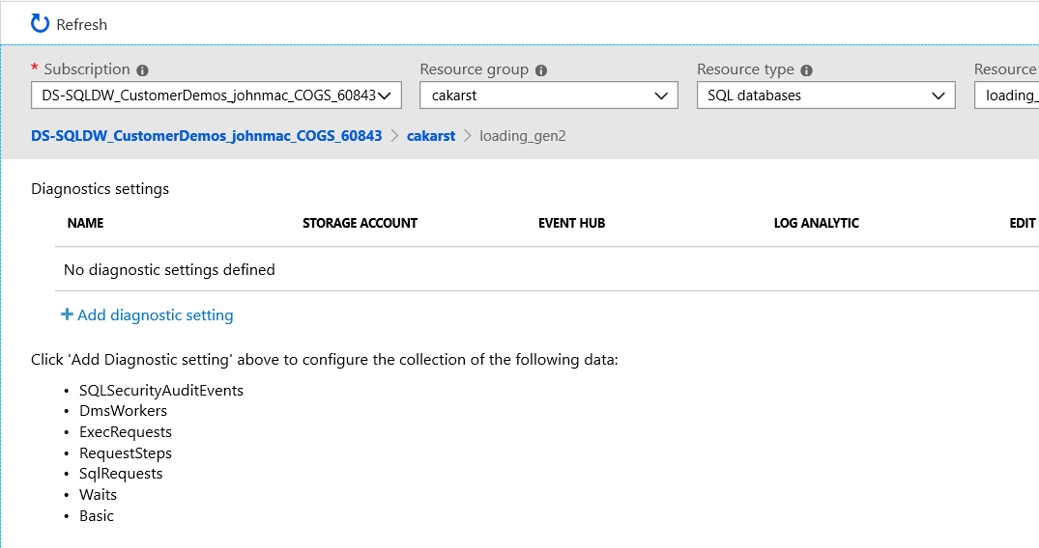

Click on the “Add diagnostic setting” in the blade

Provide a name for your diagnostics

* Check Send to Log Analytics
* Select all options under LOG

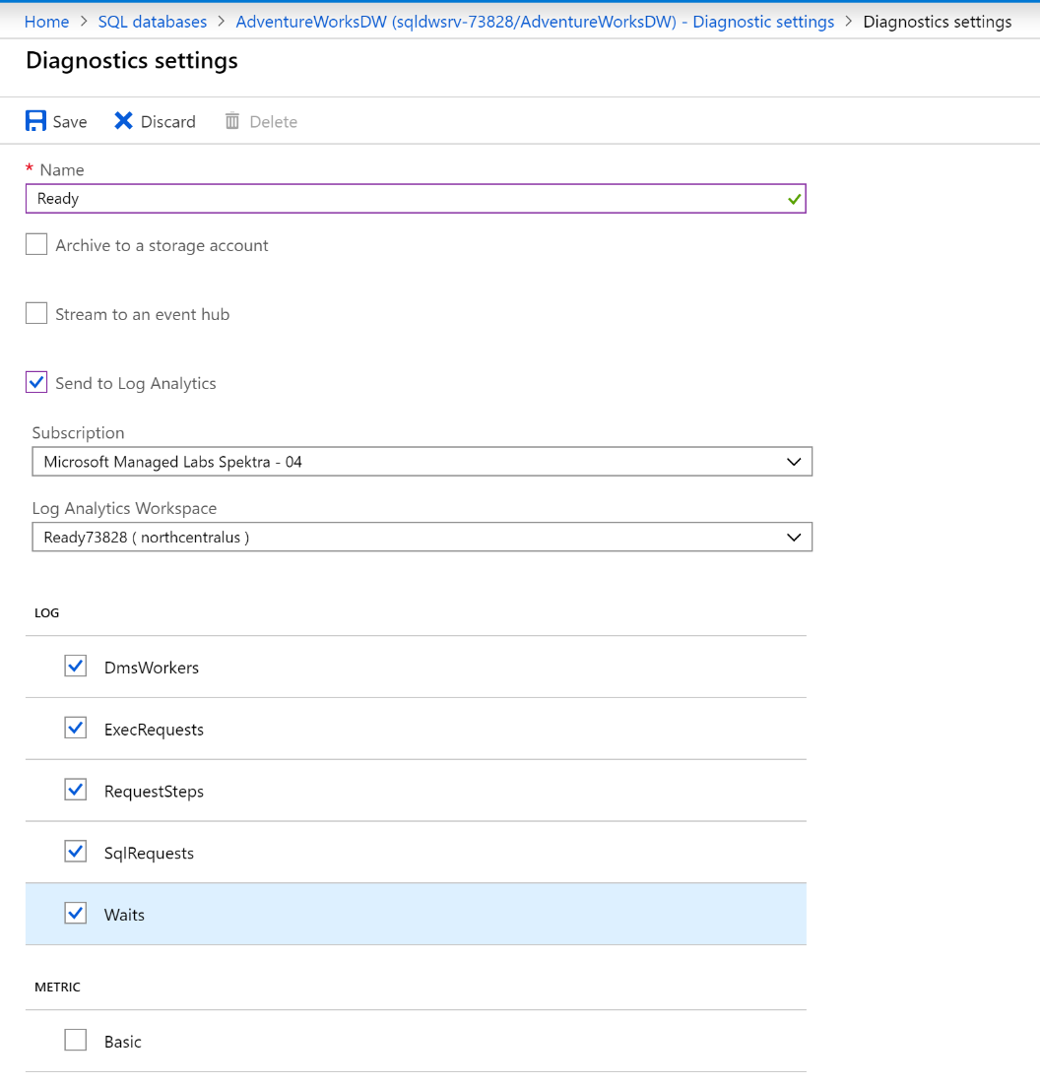

Click Save on Diagnostics settings blade

Click refresh on Diagnostic settings blade to see your new diagnostics

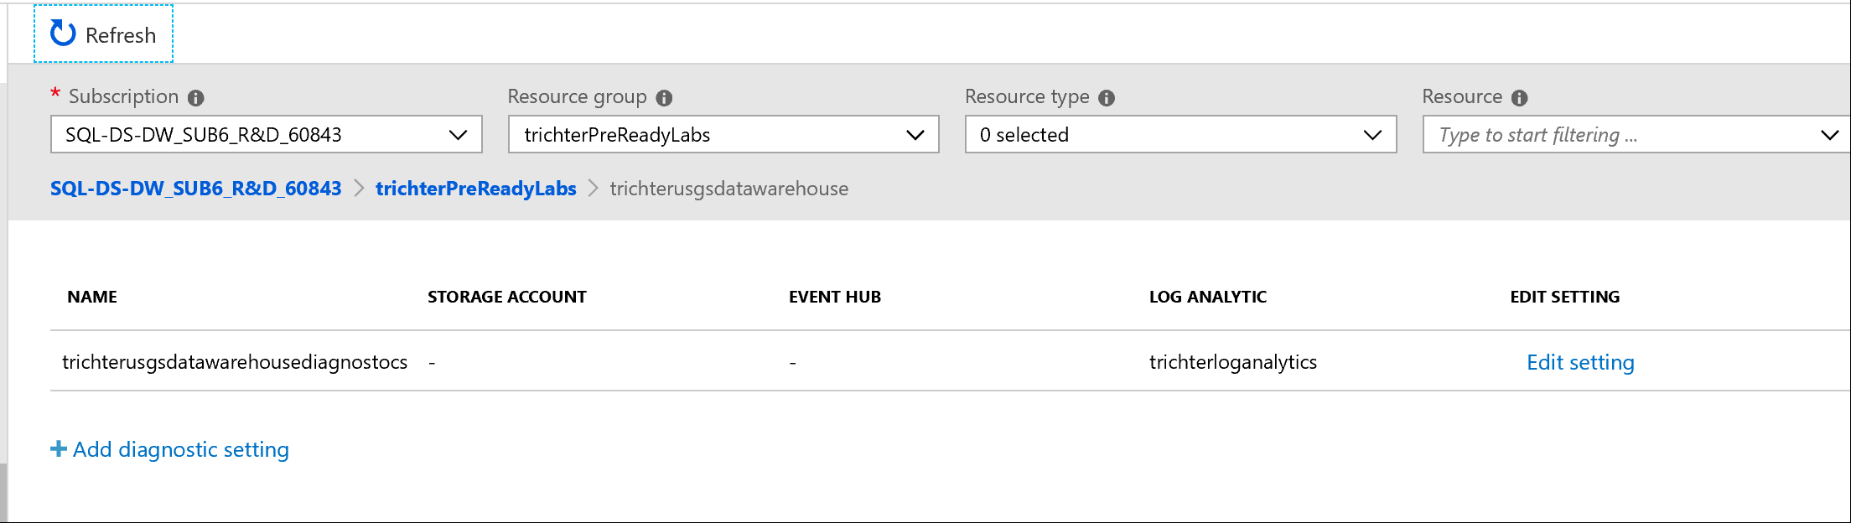

**Congratulations! You are ready to dive into labs now 😊**

**Lab modules:**

Lab 1: Data Loading Scenarios and Best Practices

* Impact of File Format on Loading
* Impact of Single File Compression
* Impact of Table Distribution
* DMVs to review Load Speeds
* Impact of CTAS vs INSERT INTO SELECT
* COPY Command (out soon)

Lab 2: Performance Tuning Best Practices

* Replicated Table Behavior
* Performance Tuning
* Resource Class Usage
* Result Set Caching

Lab 3: Monitoring, Maintenance and Security

* Resource Monitoring in Azure Monitor
* Azure Data Studio SQLDW Dashboard (Azure SQL Data Warehouse Insights)
* Azure SQL Data Warehouse Table and Statistics Queries
* Create User-defined Restore Points
* Maintenance Window Scheduling, Service Health, Service Health Alerts
* Querying ADW Diagnostic Logs using Azure Monitor